Writing c# driver for Phidget

<http://www.phidgets.com/>

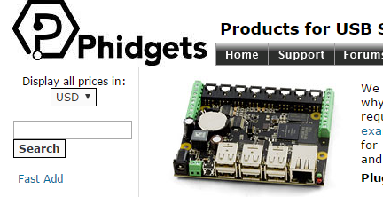

Go to the download area and download driver for windows

As we can see phidget supports many OS

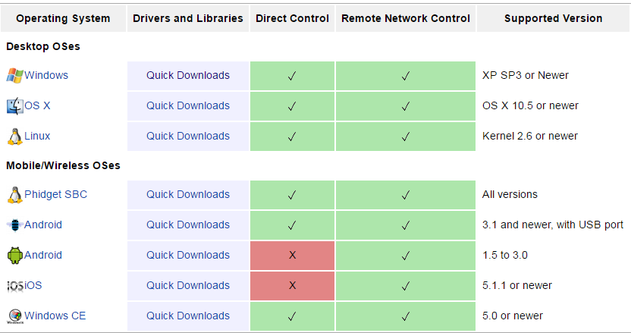

Select your target OS

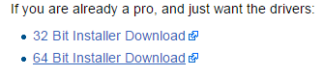

Add a c# reference to Phidget21.NET.dll

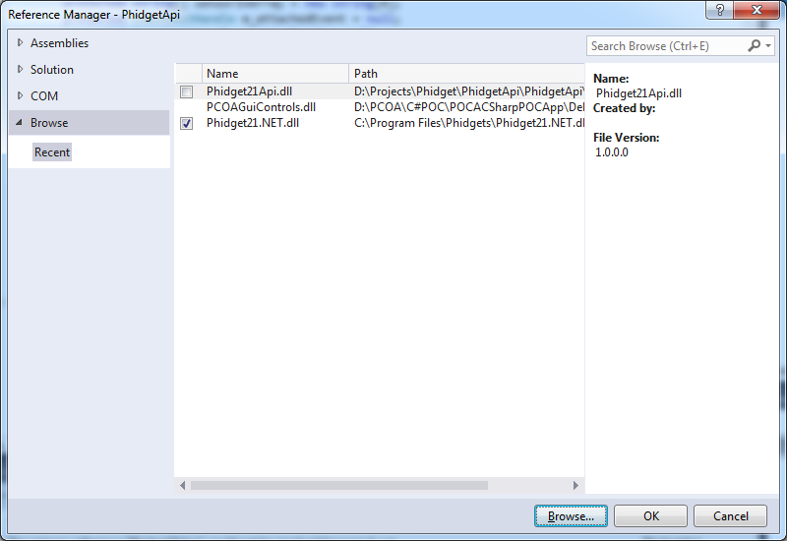

The project structure is:

We have Phidget21 class

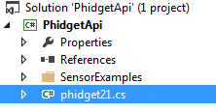

And all the Sensor examples

Phidget is a device that have digital , analog and more adapters

To use the API we can inherit from it and just call the function as group:

public class HWSwitches : Phidget21

{

public void MotorRun()

{

SetOutput(1, false);

SetOutput(2, false);

SetOutput(3, false);

}

public void State1()

{

SetOutput(1, false);

SetOutput(2, false);

SetOutput(3, true);

}

public void State2()

{

SetOutput(1, false);

SetOutput(2, true);

SetOutput(3, false);

}

public void OFF()

{

SetOutput(1, true);

SetOutput(2, false);

SetOutput(3, false);

}

public void EnableFan(bool enable)

{

SetOutput(0, enable);

}

}

For example , the GPIO 1,2,3 in 0 (false) will run the motor.

To use the code, we need phidget21.dll

The DLL is a C native dll that should be or in the PATH or in the current directory

To use the class lib, create a console app or windows form and add the refrence to the project.